**Final Project: Photo Descriptions**

**Name:** Daniel Cregg

**Student ID:** G00123456

# Competition Photograph

**Photo Title:** Craic agus Ceol

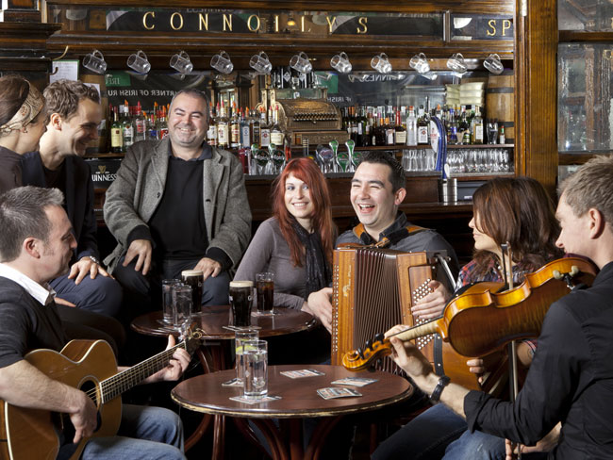

**Equipment used:** Canon 750d, RF Filter

**Photo Description/Objective:** I am submitting this photo as part of the photo competition section. This photo matches the theme because… I chose this photo because…

**Composition Details:** For this photo I chose a composition of balance. You will notice subjects are evenly distributed across the photograph. I also incorporate the element of lines…

**Technical Details:**

I used manual focus to take this shot as the room was not well lit. I had OIS turned on as I had no tripod and what to avoid handshake blur….

* **ISO** – I used an ISO of 200 because…
* **Shutter Speed** – For this Photo I chose a shutter speed of 1/800s which helped me create a sharp clean image….
* **Aperture** – I use a wide aperture f1.4 to create a bokeh effect which helped bring out my subjects.

# Creative Photographs

## Sequence Photography Narrative

**Photos Title:** Surfs Up

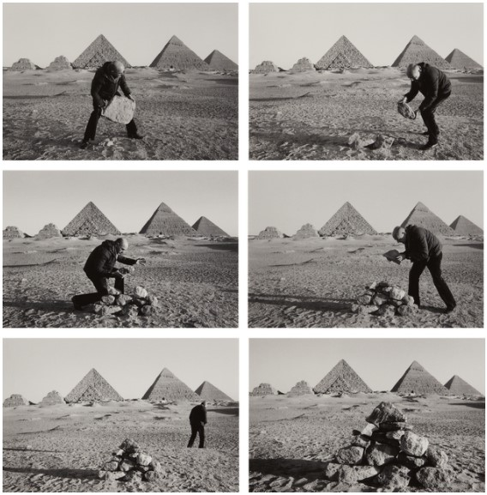

**Equipment used:** Canon 750d, Tripod

**Photo Description/Objective:** I am submitting this photo as part of the sequence photography narrative section. This photo matches the theme because… I chose this photo because…

**Composition Details:** For this photo I chose a composition of simplicity. You will notice few colours and subjects across the photograph. I also incorporate the element of lines…

**Technical Details:**

I used auto focus to take this shot as we were in well lit area. I had OIS turned on as I had no tripod and what to avoid handshake blur….

* **ISO** – I used an ISO of 100 because…
* **Shutter Speed** – For this Photo I chose a shutter speed of 1/800s which helped me create a sharp clean image….
* **Aperture** – I use a wide aperture f1.4 to create a bokeh effect which helped bring out my subjects.

## Long Exposure Photo

**Photo Title:** Busy Night

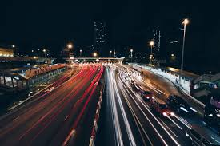

**Equipment used:** Canon 750d, Tripod

**Photo Description/Objective:** I am submitting this photo as part of the long exposure photograph section. This photo matches the theme because… I chose this photo because…

**Composition Details:** For this photo I chose a composition of balance. You will notice red lights on the left balanced by white on the right... I also incorporate the element of lines…

**Technical Details:**

I used manual focus to take this shot as it was very dark and the camera struggled to auto focus. I had OIS turned on and I used a tripod to avoid handshake blur….

* **ISO** – I used an ISO of 100 because…
* **Shutter Speed** – For this Photo I chose a shutter speed of 1/800s which helped me create a sharp clean image….
* **Aperture** – I use a wide aperture f1.4 to create a bokeh effect which helped bring out my subjects.